

DLL Instruction


Content

1. Description of the Dynamic Library 3
2. Description of “btlock57.dll” Library Function (Language: DelPhi7) 3
2.1. Writing Card Function 3
2.1.1. Function 3
2.1.2. Explain 3
2.2. Read Card Function 5
2.2.1. Function 5
2.2.2. explain 5
2.3. Conversion of a Binary String into a Hexadecimal String 6
2.3.1. Function 6
2.4. Conversion of a Hexadecimal String into a Binary String 6
2.4.1. Function 6
2.5. Conversion Time into Integer String 7
2.5.1. Function 7
2.5.2. Explain 7
2.6. Buzzer of encoder function 7
2.6.1. Function 7
2.6.2. Explain 7
2.7. Writing guest powerswitch 7
2.7.1. Function 7
2.7.2. Explain 7
2.8. Read guest power switch 8
2.8.1. Function 8
2.8.2. Explain 8
2.9. Write elevator control information function 9
2.9.1. Function 9
2.9.2. Explain 9
2.10. Read elevator control information function 10
2.10.1. Function 10
2.10.2. Explain 10
3. Code of Function Error 11
4. Other Instructions 11
5. Writing Flow 12
6. Reading flow 12
7. Additional explanations 13
7.1. How to use DEMO 13
7.1.1. Select correct Reader type (normally is RW-41) 13
7.1.2. Fill the HotelPwd (HotelPwd is system ID, which is got from Be-Tech distributor, if the system ID is not changed when make the program, it is no need to fill anything.) 13
7.1.3. Sector No. (normally is 0) 13
7.2. For Door clock only. 13
7.2.1. Click “ Card Content”, which for door lock information. 13
7.2.2. The key figures for opening the lock for Be-Tech locks in Card Content are: 13
7.3. For Door lock and Lift control 15
7.3.1. Card content 15
7.3.2. Lift content 15

Description of the Dynamic Library
- Card type suitable the dynamic library interfaces: MF1S50 cards.
- The file “btlock57.dll” is used to call the dynamic library for reading and writing card function.
- The file “zymsr232.dll” is the driver used to call RW-21 encoder with serial port.
- The file “Zymurusb.dll” and “EasyD12_500.dll” are the driver used to call RW-33 encoder with USB port.
- The file “Btmf1232.dll” is the driver used to call RW-26 encoder with serial port.
- The file “Acr120u.dll” and “AcsReader.dll” are the driver used to call RW-41 encoder with USB port.

Description of “btlock57.dll” Library Function (Language: DelPhi7)

Writing Card Function

Function
Write_Guest_Card(Port, ReaderType, SectorNo: Byte; HotelPwd: PChar; CardNo, GuestSN, GuestIdx: Integer; DoorID, SuitDoor, PubDoor, BeginTime, EndTime: PChar): Integer;

Explain

Port (scope from 1 to 4)
If the encoder is serial port, fill in value. 1~4 represent COM1, COM2, COM3 and COM4 respectively. If the encoder is USB port, the port value is not effective.

ReaderType
The value is setting in according with encoder type.
1 = RW-21;
2 = RW-33;
3 = RW-26B;
4 = RW-41.

SectorNo (scope from 0 to 15)
The number of sector of Mifare Card is setting in according with operation conditions. (Default value is 0.)

HotelPwd
The hotel password (HotelPwd) is provided by the hotel.
The value is 6-digit character string which with the content of ACSⅡ.

CardNo (scope from 1 to 4294967296)
Guest card number is provided by PMS.

GuestSN (scope from 1 to 4294967296)
Guest serial number is generated in according with computer time. Convert the time of computer to 4 bits integer serial number via“SerialNo_FromNow”function.
Replace function: a guest card with a larger serial number can replace a guest card with a smaller serial number.

GuestIdx (scope from 1 to 255)
Guest sequence number indicates different sequence numbers of simultaneously used guest cards with the same room.

DoorID (6-digit character string)
Room number is provided by the hotel. There is a corresponding table for the numbers and names of the rooms in door lock software.

SuitDoor

Introduction
Inner door No. of a suite room is the code string of inner doors that can be opened by a guest card in a suite room. Its length is 4 and the default value is “0000”. A guest card can open up to 16 inner doors and 1 outer door of a suite room.

Calculation
Check each digit in the code from right to left to see if it can open the corresponding inner door of the suite, if it can, set it as “1”, if not, set it as “0”. At last, combine them into a hexadecimal string.

Example
If the first six digits of the lock codes of two or more rooms in a door lock system are identical, it indicates that suite rooms are set in the door lock system. If no suite room is set in the lock system, or it is not necessary to open inner doors (all guest cards can open external doors of suite rooms), it can be filled inner default value “0000”. If a guest card can open No.01, No.02, No. 07 and No.08 inner doors of a suite room, the binary string will be “0000 0000 1100 0011”, which can be converted into a hexadecimal-string: “00C3”.

PubDoor

Introduction
Common door No. is the inner door No. of a suite room that can be opened by a guest card, the length is 8; the default value is “00000000”. The guest card can open up to 32 common doors.

Calculation
Check each digit in the code from right to left to see if it can open the corresponding common door, if it can, set it as “1”, if not, set it as “0”. At last, combine them into a hexadecimal string.

Example
If no suite room is set in the system, or it is not necessary to open inner doors, it can be filled inner default value “00000000”.If a guest card can open No.01, No.08, No. 15 common doors, the binary string will be “0000 0000 0000 0000 0100 0000 1000 0001”, which can be converted into a hexadecimal-string: “00004081”.

BeginTime
Effective begin time, the length is 10, the time format is “ _ _ (year) _ _ (month) _ _ (date) _ _(hour)_ _ (minute)”.

EndTime
Effective end time, the length is 10, the time format is “ _ _ (year) _ _ (month) _ _ (date) _ _ (hour)_ _ (minute)”.

Read Card Function

Function
Read_Guest_Card(Port, ReaderType, SectorNo: Byte; HotelPwd: PChar; var CardNo, GuestSN, GuestIdx: Integer; DoorID, SuitDoor, PubDoor, BeginTime, EndTime: PChar): Integer

explain

Port (scope from 1 to 4)
If the encoder is serial port, fill in value. 1~4 represent COM1, COM2, COM3 and COM4 respectively. If the encoder is USB port, the port value is not effective.

ReaderType
The value is setting in according with encoder type.
1 = RW-21;
2 = RW-33;
3 = RW-26B;
4 = RW-41.

SectorNo (scope from 0 to 15)
The number of sector of Mifare Card is setting in according with operation conditions. (Default value is 0.)

HotelPwd
The hotel password (HotelPwd) is provided by the hotel.
The value is 6-digit character string which with the content of ACSⅡ.

CardNo (scope from 1 to 4294967296)
Guest card number is provided by PMS.

GuestSN (scope from 1 to 4294967296)
Guest serial number is generated by according to computer time. Convert the time of computer to 4 bits integer serial number via“SerialNo_FromNow”function.
Replace function: a guest card with a larger serial number can replace a guest card with a smaller serial number.

GuestIdx (scope from 1 to 255)
Guest sequence number indicates different sequence numbers of simultaneously used guest cards with the same room.

DoorID (6-digit character string)
Room number is provided by the hotel. There is a corresponding table for the numbers and names of the rooms in door lock software.

SuitDoor

Introduction
Inner door No. of a suite room is the code string of inner doors that can be opened by a guest card in a suite room. Its length is 4 and the default value is “0000”. A guest card can open up to 16 inner doors and an outer door of a suite room.

Calculation
Check each digit in the code from right to left to see if it can open the corresponding inner door of the suite, if it can, set it as “1”, if not, set it as “0”. At last, combine them into a hexadecimal string.

Example
If the first six digits of the lock codes of two or more rooms in a door lock system are identical, it indicates that suite rooms are set in the door lock system. If no suite room is set in the lock system, or it is not necessary to open inner doors (all guest cards can open external doors of suite rooms), it can be filled in the default value “0000”.If a guest card can open No.01, No.02, No. 07 and No.08 inner doors of a suite room, the binary string will be “0000 0000 1100 0011”, which can be converted into a hexadecimal-string：“00C3”.

PubDoor

Introduction
Common door No. is the inner door No. of a suite room that can be opened by a guest card, the length is 8; the default value is “00000000”. The guest card can open up to 32 common doors.

Calculation
Check each digit in the code from right to left to see if it can open the corresponding common door, if it can, set it as “1”, if not, set it as “0”. At last, combine them into a hexadecimal string.

Example
If no suite room is set in the system, or it is not necessary to open inner doors, it can be the default value “00000000”. If a guest card can open No.01, No.08, No. 15 common doors, the binary string will be “0000 0000 0000 0000 0100 0000 1000 0001”, which can be converted into a hexadecimal-string：“00004081”.

BeginTime
Effective begin time, the length is 10, the time format is “_ _ (year) _ _ (month) _ _ (date) _ _(hour)_ _ (minute)”.

EndTime
Effective end time, the length is 10, the time format is “_ _ (year) _ _ (month) _ _ (date) _ _(hour)_ _ (minute)”.

Conversion of a Binary String into a Hexadecimal String

Function
Bin_Hex(Dest: PChar; Source: PChar; Len: Integer): Integer
- Explain: change binary character string to hexadecimal character string.
- Dest: Destination hexadecimal character string.
- Source: Source binary character string.
- Len: Length of the source character string.
- Parameter return value: 0 indicates successful conversion, -1 indicates conversion failure.

Conversion of a Hexadecimal String into a Binary String

Function
Hex_Bin(Dest: PChar; Source: PChar; Len: Integer): Integer
- Explain: change hexadecimal character string to binary character string.
- Dest: Destination binary character string.
- Source: Source hexadecimal character string.
- Len: Length of the source hexadecimal character string.
- Parameter return value: 0 indicates successful conversion, -1 indicates conversion failure.

Conversion Time into Integer String

Function
SerialNo_FromNow():Integer;

Explain

Convert the time of computer to 4 bits integer serial number via“SerialNo_FromNow”function. The value must be positive number.

Parameter return value: > 0

Buzzer of encoder function

Function
Reader_Alarm (Port, ReaderType, AlarmCount: Byte):Integer;

Explain

Port
If the encoder is serial port, fill in value. 1~4 represent COM1, COM2, COM3 and COM4 respectively. If the encoder is USB port, the port value is not effective.

ReaderType
The value is setting in according with encoder type.
1 = RW-21;
2 = RW-33;
3 = RW-26B;
4 = RW-41.

AlarmCount
The times of alarm by PMS (scope from 1~255)

Writing guest powerswitch

Function
Write_Guest_PowerSwitch(Port, ReaderType, SectorNo: Byte; PowerSwitchPwd: PChar; CardNo, GuestSex: Integer; DoorID,GuestName, BeginTime, EndTime: PChar): Integer;

Explain

Port (scope from 1 to 4)
If the encoder is serial port, fill in value. 1~4 represent COM1, COM2, COM3 and COM4 respectively. If the encoder is USB port, the port value is not effective.

ReaderType (scope from 1 to 4)
The value is setting in according with encoder type.
1 = RW-21;
2 = RW-33;
3 = RW-26B;
4 = RW-41.

SectorNo (scope from 0 to 15)
The number of sector of Mifare Card is setting in according with operation conditions. (Default value is 0.)

PowerSwitchPwd
The value is setting in according with power switch settings. (Default value is FF FF FF FF FF FF )
The value is 12-digit character string which with the content of hexadecimal.

CardNo (scope from 1 to 4294967296)
Guest card number is provided by PMS.

GuestSex
0 = man;
1 = woman

DoorID (6-digit character string)
Room number is provided by the hotel. There is a corresponding table for the numbers and names of the rooms in door lock software.

GuestName（6-digit character string）

BeginTime
Effective begin time, the length is 10, the time format is “_ _ (year) _ _ (month) _ _ (date) _ _(hour)_ _ (minute)”.

EndTime
Effective end time, the length is 10, the time format is “_ _ (year) _ _ (month) _ _ (date) _ _(hour)_ _ (minute)”.

Read guest power switch

Function
Read_Guest_PowerSwitch(Port, ReaderType, SectorNo: Byte; PowerSwitchPwd: PChar; var CardNo, GuestSex: Integer; DoorID, GuestName, BeginTime, EndTime: PChar): Integer

Explain

Port (scope from 1 to 4)
If the encoder is serial port, fill in value. 1~4 represent COM1, COM2, COM3 and COM4 respectively. If the encoder is USB port, the port value is not effective.

ReaderType (scope from 1 to 4)
The value is setting in according with encoder type.
1 = RW-21;
2 = RW-33;
3 = RW-26B;
4 = RW-41.

SectorNo (scope from 0 to 15)
The number of sector of Mifare Card is setting in according with operation conditions. (Default value is 0.)

PowerSwitchPwd
The value is setting in according with power switch settings. (Default value is FF FF FF FF FF FF )
The value is 12-digit character string which with the content of hexadecimal.

CardNo (scope from 1 to 4294967296)
Guest card number is provided by PMS.

GuestSex
0 = man;
1 = woman

DoorID (6-digit character string)
Room number is provided by the hotel. There is a corresponding table for the numbers and names of the rooms in door lock software.

GuestName（6-digit character string）

BeginTime
Effective begin time, the length is 10, the time format is “_ _ (year) _ _ (month) _ _ (date) _ _(hour)_ _ (minute)”.

EndTime
Effective end time, the length is 10, the time format is “_ _ (year) _ _ (month) _ _ (date) _ _(hour)_ _ (minute)”.

Write elevator control information function

Function
Write_Guest_Lift(Port, ReaderType, SectorNo: Byte; HotelPwd: PChar; CardNo, BeginAddr, EndAddr, MaxLiftAddr: Integer; BeginTime, EndTime, LiftData: PChar): Integer;

Explain

Port (scope from 1 to 4)
If the encoder is serial port, fill in value. 1~4 represent COM1, COM2, COM3 and COM4 respectively. If the encoder is USB port, the port value is not effective.

ReaderType
The value is setting in according with encoder type.
1 = RW-21;
2 = RW-33;
3 = RW-26B;
4 = RW-41.

SectorNo (scope from 0 to 15)
The number of sector of Mifare Card is setting in according with operation conditions. (Default value is 0.)

HotelPwd
The hotel password (HotelPwd) is provided by the hotel.
The value is 6-digit character string which with the content of ACSⅡ.

CardNo (scope from 1 to 4294967296)
Guest card number is provided by PMS.

BeginAddr：
The begin address of elevator information, please find out this value in the lift setting card in Be-tech software, converse the value from Hexadecimal to Decimal

EndAddr：
The end address of elevator information, please find out this value in the lift setting card in Be-tech software, converse the value from Hexadecimal to Decimal

MaxLiftAddr：
All of the max lift address value, please find out this value in the lift setting card in Be-tech software, converse the value from Hexadecimal to Decimal

BeginTime：
Effective begin time, the length is 10, the time format is “ _ _ (year) _ _ (month) _ _ (date) _ _(hour)_ _ (minute)”.

EndTime
Effective end time, the length is 10, the time format is “ _ _ (year) _ _ (month) _ _ (date) _ _ (hour)_ _ (minute)”.

LiftData：
Elevator control information, we need begin address and end address, you need to get the begin address and end address in be-tech system life management. The begin address and end address are hexadecimal, we have to converse the decimal to hexadecimal. For example: if you see begin address and end address are 60, 61 in the software, so you have to converse them to 96, 97 in the interface. If there are 16 floors in this elevator control, the card can go to floor 1, 2, 7, 8, then the binary string is 1100 0011 0000 0000, (0 stand for not invalid, 1 stand for valid), converse to hexadecimal string is C300

Read elevator control information function

Function
Read_Guest_Lift(Port, ReaderType, SectorNo: Byte; HotelPwd: PChar; BeginAddr, EndAddr: Integer; var CardNo: Integer; BeginTime, EndTime, LiftData: PChar): Integer;

Explain

Port (scope from 1 to 4)
If the encoder is serial port, fill in value. 1~4 represent COM1, COM2, COM3 and COM4 respectively. If the encoder is USB port, the port value is not effective.

ReaderType
The value is setting in according with encoder type.
1 = RW-21;
2 = RW-33;
3 = RW-26B;
4 = RW-41.

SectorNo (scope from 0 to 15)
The number of sector of Mifare Card is setting in according with operation conditions. (Default value is 0.)

HotelPwd
The hotel password (HotelPwd) is provided by the hotel.
The value is 6-digit character string which with the content of ACSⅡ.

CardNo (scope from 1 to 4294967296)
Guest card number is provided by PMS.

BeginAddr：
The begin address of elevator information, please find out this value in the lift setting card in Be-tech software, converse the value from Hexadecimal to Decimal

EndAddr：
The end address of elevator information, please find out this value in the lift setting card in Be-tech software, converse the value from Hexadecimal to Decimal

MaxLiftAddr：
All of the max lift address value, please find out this value in the lift setting card in Be-tech software, converse the value from Hexadecimal to Decimal

BeginTime：
Effective begin time, the length is 10, the time format is “ _ _ (year) _ _ (month) _ _ (date) _ _(hour)_ _ (minute)”.

EndTime
Effective end time, the length is 10, the time format is “ _ _ (year) _ _ (month) _ _ (date) _ _ (hour)_ _ (minute)”.

LiftData：
Elevator control information, we need begin address and end address, you need to get the begin address and end address in be-tech system life management. The begin address and end address are hexadecimal, we have to converse the decimal to hexadecimal. For example: if you see begin address and end address are 60, 61 in the software, so you have to converse them to 96, 97 in the interface. If there are 16 floors in this elevator control, the card can go to floor 1, 2, 7, 8, then the binary string is 1100 0011 0000 0000, (0 stand for not invalid, 1 stand for valid), converse to hexadecimal string is C300

Code of Function Error
- 0: Success
- 255: Failure
- 1: Open serial com port error
- 2: No card error
- 3: Card type error
- 4: Read card error
- 5: Hotel password error
- 6: Write card error

Other Instructions
- The hotel password (HotelPwd) is provided by the hotel.
- The room number is provided by the hotel. There is a corresponding table for the numbers and names of the rooms in door lock software.
- The guest serial No.(scope from 1 to 4294967296)is generated by according to time or adding one to the current accumulated number, and a guest card with a larger serial number can replace a guest card with a smaller serial number.(Note: the PCB of 2083M-ZJ3 and 2212M-ZJ3 only work on the Calculation that generate by adding one to the current accumulated number.)
- Guest sequence No.(scope from 1 to 255) indicate different sequence numbers of simultaneously used guest cards with the same room.
- If the hotel password is changed，use six digits in the password and only numerical digits can be used.
- The effective time value must be 10 digits arranged as following: year/month/date/hour/minute
- The value of default sector of Mifare S50 is 0. Please fill in the corresponding sector number when the sector of the hotel has changed.

Writing Flow
Write guest card information
Write_Guest_Card

Write power switch information (option)
Write_Guest_ PowerSwitch

Reader_Alarm
Buzzer alarm after writing

Reading flow
Read guest card information

Read_Guest_Card

Read power switch information (option)

Read _Guest_ PowerSwitch

Reader_Alarm
Buzzer alarm after reading

Additional explanations

How to use DEMO

Select correct Reader type (normally is RW-41)

Fill the HotelPwd (HotelPwd is system ID, which is got from Be-Tech distributor, if the system ID is not changed when make the program, it is no need to fill anything.)

Sector No. (Normally is 0)

For Door clock only.
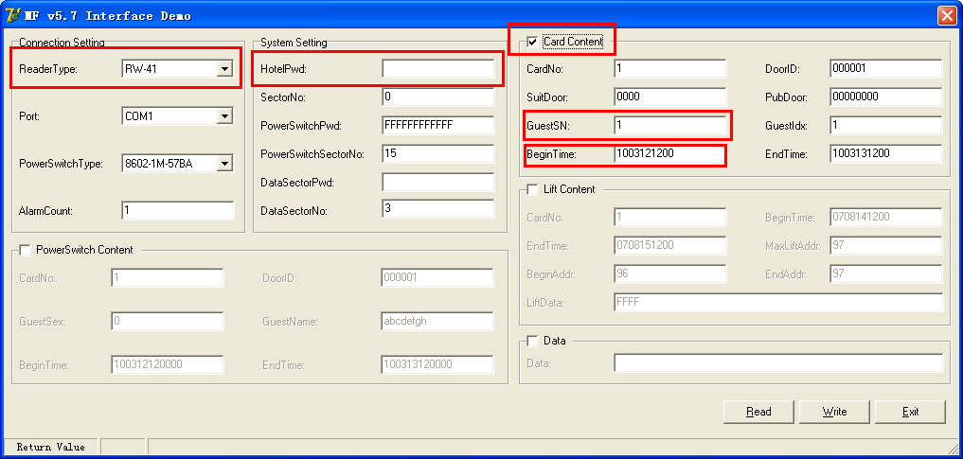

Click “ Card Content”, which for door lock information.

The key figures for opening the lock for Be-Tech locks in Card Content are:

Door ID
Must be 6 numbers, you can get all of room IDs from Be-Tech smart locking system
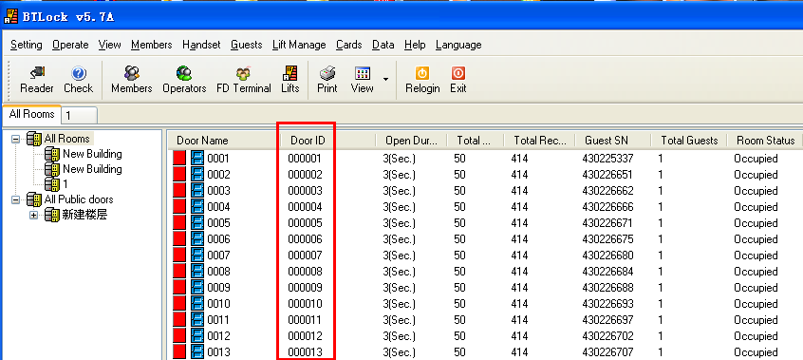

Begin Time
Follow the time format to program the time. Do not set the computer current time to begin time, you should take a begin time is 30 mins before computer time. For example, the computer time is 9:00am, so you should make the begin time to the cards is 8:30am

End Time:
Follow the time format to program the time,

Guest SN:
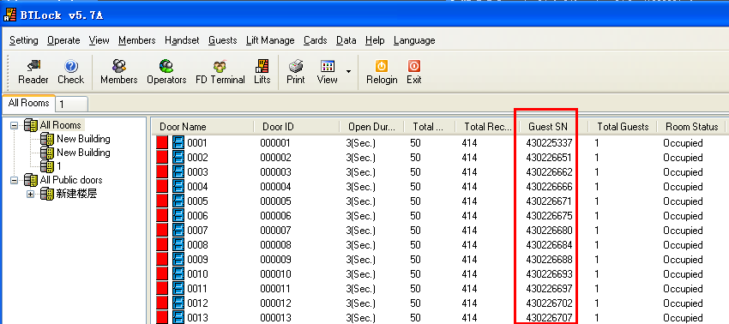
When a guest check-in, guest SN is created. When new guest check-in with same room, the guest SN of new guest card should be bigger that old guest’s, so when new guest card open the lock, and old guest card is our of use.
When there are more than one guest in a room, make sure all of the guest cards with same guest SN, so that they can open a same lock.
For example: there are two guests in a same room, you need to issue two cards for them. Make sure the following parameters of two cards are correct:
- Same Door ID
- Same begin time and end time
- Same guest SN
- Different Care No.
- Different Card Index (The first guest card should be 1, the second guest card should be 2....)

For Door lock and Lift control
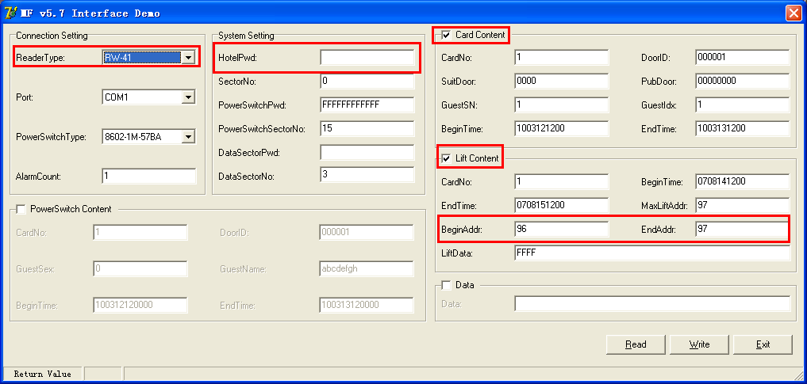

Card content
Please check item 7.2

Lift content

Cardno. Should be same as card content’s

Endtime and begin time shoud be same as cards content’s.

MaxLiftAddr is from be-tech software see below

Beginaddr and EndAddr are from be-tech software, see below
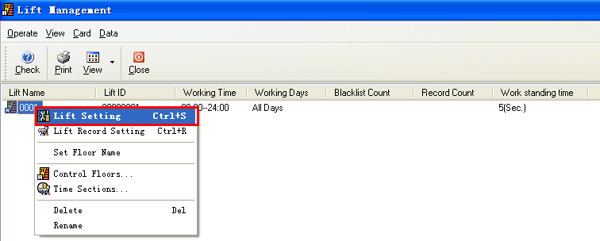

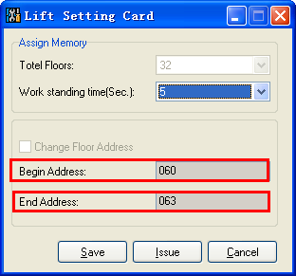

You can see the begin address in Hex, you need to convert it into Decimal, and fill these values to the corresponding form.

For example:
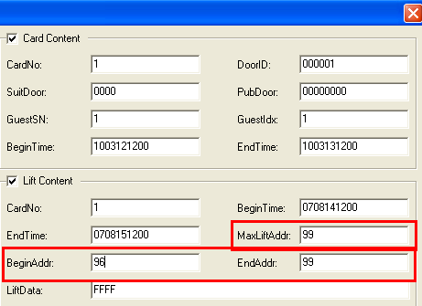

You find out the begin address and end address on lift setting card, there are 060 and 063, you need to convert them to decimal, and fill to the form

